**How to play Card 24**

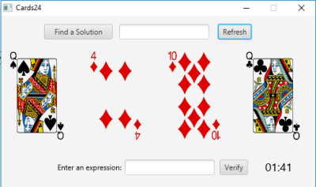

**Objective**: - Use the 4 random playing cards you receive from a total of 52 cards

- The goal is to use Addition, Subtraction, Multiplication, Division and parenthesis to end up with the number 24 as soon as possible

**Rules**:

* You can only use the numbers once
* You can use Addition, Subtraction, Multiplication, Division, and Parenthesis
* Click the “Verify” button to validate if your expression is correct
* The expression must evaluate to 24

**Legend**:

A) Numbers: (2-10)

B) Ace is: *1*

C) Jack is: *11*

D) Queen is: *12*

E) King is: *13*

**Example**:

You pick the numbers (9, 6, 3, 2)

A few solutions you can do to solve this are:

(9-3-2) × 6 = 24

6×2+9+3 =24

(3-2/6) ×9 = 24